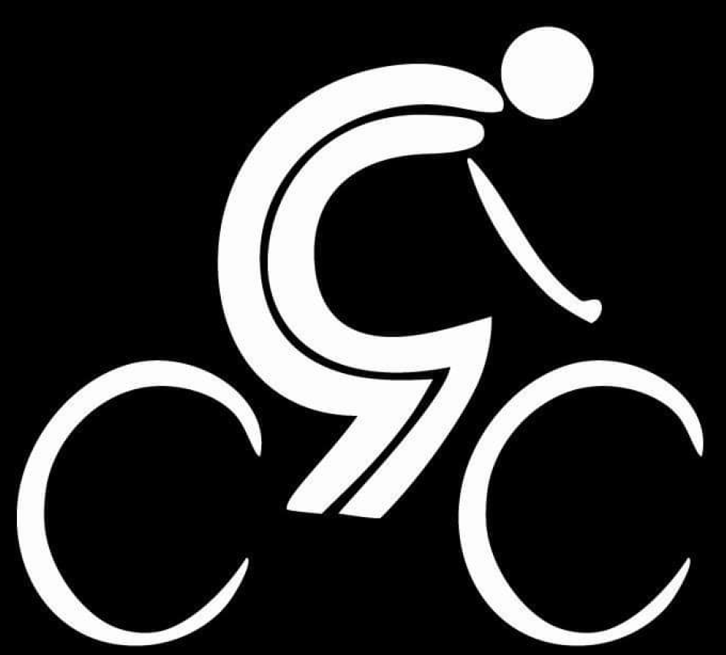
GGCC Award list for 2019
Introduction
2019………the best so far?
In August of 2011 I had a wee idea to give a cycling club a try and after lots of admin, research, behind the scenes organising a phone call to Ray to say……this has already grown arms and legs…..’do you want in!?’………we turned up at Glasgow Green at 8.30 and 1 person pitched up…..Danny Cartledge….we did the north route that day!
Next time there was 8……..and the rest is history!
One of the most respected and successful clubs not only in Scotland but in the UK……a finalist in the CW 2019 Awards for Cycling Club of the Year.
We have a simple formula………we talk, we suggest, we try, we agree……we sometimes disagree……we adapt, we develop and we evolve as a club……..our formula is simple and everyone knows what we do, how we do it and why….and it just works so don’t fix what aint broke
We have produced national champs, national record breakers, cat 2 racers, professional racers, commissaires, podium winners, superbly talented bike riders, fast hill climbers, chain gang aficionados, steady eddie’s, respectful road users, lifelong friends, husbands and wife’s, GGCC babies….the list goes on but I hope we have all produced a club that I hope you can be proud of…….remember its you lot….the GGCC members that make it what it is
We are here to celebrate what has been a beyond awesome year for the club so before we start I want to thank each and every one of you for your continued support…….the 50 plus riders that turn out come rain, hail or shine to ride bikes with your pals….makes me very proud
Another year goes by where I haven’t been out as much as I should have been so a special thanks to the ride leaders who step up to look after the groups but I want to say a special thanks to the Road Captains.
Can you say thanks to Mark Gallagher and Robert Hamilton but also say ‘hello, welcome and thanks’ to Chris Ditchfield and Ian Linden who complete the 4 strong Road Captain team……..without these 4 guys, well……..my life wouldn’t be as easy that’s for sure!
The awards recognise folk in the club that have demonstrated that little bit extra, gone that extra mile possibly, completed something really special or just been a bit pf a legend…..BUT………that doesn’t mean the rest of you haven’t…….GGCC is known for its open, welcoming and friendly atmosphere so each and every one of you deserve an award in my opinion………but I cant do that or the buffet will get cold and you will all get bored of my chat!
So……….2019……….lets give out some awards folks!
General Awards

_{Group Leader Award} ₋ _{Paul Devlin}
_{Group Leader Award} ₋ _{Steve Hutton}
_{Group Leader Award} ₋ _{Kenny Blair}
Most Improved Female Club Rider - _{Stephanie Kyle}
Most Improved Male Club Rider - _{Gavin Johnston}
_{Most Consistent Club Rider} ₋ _{David Fitzpatrick}
_{Most Improved Female Racer} ₋ _{Alexandra Michnowicz}
_{Most Improved Male Racer} ₋ _{Murray Soutter}
_{Most Supportive Club Member -} _{Michael McPartlin}
_{GGCC Ambassador of the Year -} _{Nicholas Bone}
_{Outstanding Effort Award} ₋ _{Christina Murray}
_{Best Event Support} ₋ _{‘The Broons’}
_{The Biggest Contribution} ₋ _{Brian Sutton}
_{The Member’s Member Award} ₋ _{Andy Jack}

_{4 x Special Recognition awards}
_{Road Captain’s}
Robert Hamilton / Mark Gallagher / Chris Ditchfield / Ian Linden

_{Tommy Dorrian award}
_{Paul Mullan}

_{The Broons Award}
_{Richard Hogg}

_{2 x Club Championship Awards}
- So this is our 3rd year of the GGCC Club Confined Club Championship and this year has been the closest so far.
- We make sure that this is as fair a playing field as possible so Seniors, Masters and Veterans all have an equal chance of taking the title.
- Year 1 in 2017 we had Doog Carruthers and Zosia Martin take the inaugural championship awards – masters male and masters female
- Year 2 in 2018 we had Alexandra Michnowic and Micky Ross take the championship awards so a Senior female and a Veteran male
- This year we had 73 individual points scorers with 12 females scoring points and 61 males scoring points
- Consistency was the key for this years winners and across the 9 opportunities to score points the male winner scored in 7 and the female winner scored in 6
- I said last year (coz I checked my notes) that a particular individual was hired for this year and again a massive shout out and thanks goes to Gavin Morton who behind the scenes was a huge help in pulling together the myriad of data and results we had to wade through……Gavin made the very hazy at times sheets of data make absolute sense
_{Hannah Browne}
- This individual is a fairly new member to GGCC and has absolutely thrown herself into GGCC and quickly become an integral part of our club
- Club rides, Tommy Tonnes, TOTH and club competition……she really has embraced 2 wheels
- A winner in 3 of the 6 events she scored points in and second in the other 3 means she won the championship this year by 9 clear points
- The top 3 in the female competition were separated by only 12 points in total
- This person always has a beaming smile….even when she is voluntarily dealing with a fallen rider from another club at the Georgetown Cup or riding a Hill Climb straight off a night shift at the hospital
  - 3rd place with 45 points – Wee Jenny Munro
  - 2nd place with 48 points – Chrissy TT Queen Murray
  - 1st place with 57 points – Hannah ‘always smiling’ Browne
_{Andrew McIntyre}
- The best way to describe the make winner is Mr Consistency
- Club rides, challenges, club events, Tommy Tonnes, Club rides……..one of the road captains said ‘I actually cant remember a club ride when XXXXX wasn’t there’
- An outstanding cyclist that just ‘gets on with it’ but always ready to help and guide and support so has really embraced the GGCC way
- A winner of 2 of the events he scored in, second in another and 4th in the other 4 means he is club champion by 1 point……told you it was close
- The top 3 in the male competition were also only separated by 12 points in total
- This person proves that this competition is open to everyone and his efforts and results and consistency means he is our deserved winner for 2019
  - 3rd place with 45 points – Alan Clark
  - 2nd place with 56 points – Michael McPartlin
  - 1st place with 57 points – Andy McIntyre

